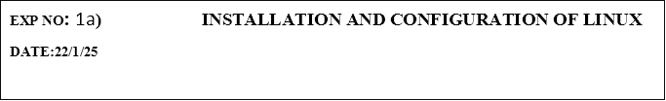

**Installation/Configuration Steps:**

1. Install the required packages for virtualization

dnf install xen virt-manager qemu libvirt

2. Configure xend to start up on boot

systemctl enable virt-manager.service

3. Reboot the machine

Reboot

4. Create Virtual machine by first running virt-manager

virt-manager &

5. Click on File and then click to connect to localhost

6. In the base menu, right click on the localhost(QEMU) to create a new VM 7. Select

Linux ISO image

8. Choose puppy-linux.iso then kernel version

9. Select CPU and RAM limits

10.Create default disk image to 8 GB

11.Click finish for creating the new VM with PuppyLinux

1

231801504                                                                                                                                          CS23431